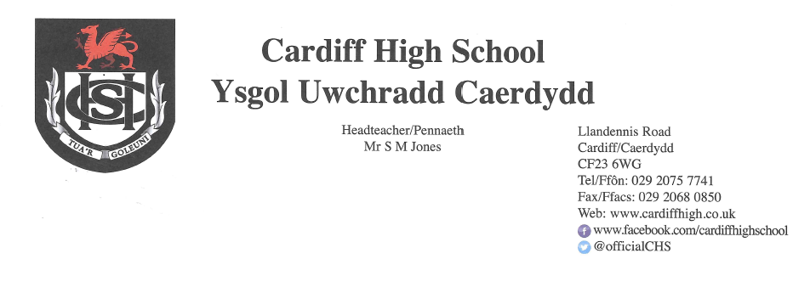
6 November 2020

Dear Parent/ Carer
I hope that your son/daughter has found their home-learning experience this week to be an enjoyable one and that they have been able to access the lessons and resources. If they have had any issues regarding this, please can you ask them to see a member of the Achievement Team on their return to school.
As you are aware, a number of positive Covid-19 cases within the sixth form were reported to the school during the last week of the half term resulting in students being required to isolate at home. As students return to school following the Welsh Government’s Firebreak, we have implemented further changes to support our bid to mitigate against the transmission of Covid-19. We would be grateful if you were to discuss these with your son/ daughter before they return on Monday.
In line with previous advice given, where possible, students should only be on site for their actual lessons. Ty Celyn, therefore will be closed to students during period 1 and period 5 each day. If students are free period 1 they should not arrive at school until their first lesson of the day and leave the site following their final lesson. If any student requires to use Ty Celyn during period 1 or period 5 due to transport issues, they must make prior arrangements with myself or Mrs Jones otherwise they will be asked to leave.
To reduce the numbers of students in Ty Celyn in the school day, students are asked to go home during their free periods where possible. For those on site, the following venues will be available:
- Ty Celyn
- Sixth form outdoor seating areas (an additional seating area has been created over the half term)
- Deli Canteen
- S22 Computer Room
During break students can also use their period 3 classroom and at lunch time the Learning Hub is available from 12.35 pm for the sixth form to use. In addition to these venues, all students are encouraged to use the silent study rooms during their free periods if they need to be on the school site. I have attached a copy of the timetable with this letter. A copy is also available on google classrooms for students.
Finally, please can you remind your son/ daughter that Ty Celyn is a work space and not a social space. We have reconfigured Ty Celyn over the last week and students are not permitted to move the furniture. When in communal areas such as Ty Celyn, students must sanitise, follow the one-way system, use keyboard wipes and wear face masks otherwise they will be asked to leave.
Thank you for your continued support in this matter. We are looking forward to welcoming back all our students on Monday 9th November to continue with their learning journey.
Yours faithfully
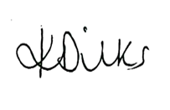
Mrs. K. Dilks
Head of Upper School

