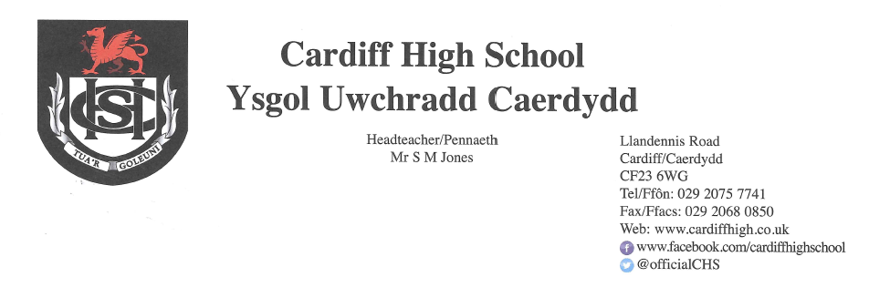

17 December 2020

Dear Parents and Carers

As you may have already seen in the press and on social media, this afternoon, Welsh Government and local councils have made announcements regarding return to school in January 2021.

Cardiff Council have instructed schools to use online learning for the week beginning 4th January 2021 in recognition of the high levels of coronavirus prevalent in the city. This means that Cardiff High students will remain at home and continue to follow their blended learning timetable from Monday 4th January until Friday 8th January. We envisage that face to face teaching will resume on Monday 11th January for all year groups, however this is subject to change, dependent on any further instructions from Welsh Government or the local council.
We appreciate that this is a change from the expectation for the start of next term; however, we hope you understand the situation the school is facing, and we are committed to keeping you informed as fully and as early as possible when plans need to be changed.
Once again, we thank you for your continued support and wish you a restful holiday.

Kind Regards

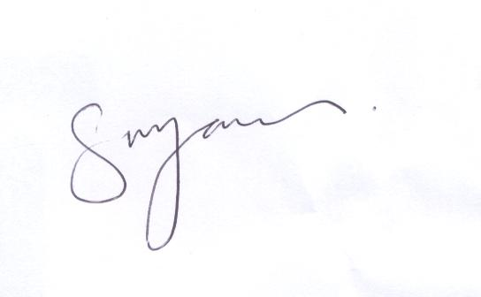

S M JONES
Headteacher

