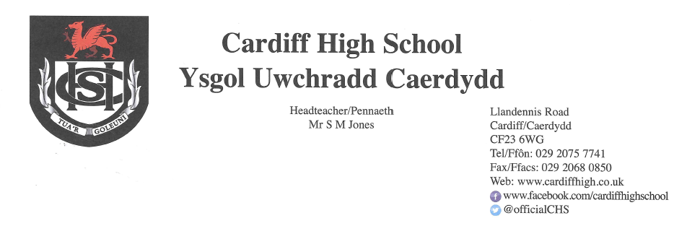
11 February 2021

Dear Parents and Carers,
As we head into the half term break I would like to express our gratitude, once again, for the level of appreciation you have shown towards the school in this incredibly challenging period and to share with you a few updates and information.
Learner Feedback
We are very grateful to the large number of pupils who recently completed the survey related to the blended learning provision. A large number of pupils in every year group participated and the feedback has been very useful in terms of shaping the provision over the coming weeks.
We were so pleased with the significant number of positive extended comments that we wanted to share a few with you:
“My favourite…self-study where the work was set out clearly, the goals were set out clearly, the mark scheme was uploaded right away and the teacher had an explanation video going through every answer. It was able to be done in the hour and was extremely useful topic revision that you could work through at your own pace.”

“… it still feels like we are in school and it’s really inclusive.”

“All of them have been good and I can’t really tell one which stood out!”

“The PowerPoints that the teacher uses are really effective in my opinion. The information on them is short and concise so it's easy to follow. They also have symbols in the corners so we know what to do (e.g. copy the slide, read, listen, etc). The teacher also makes sure everyone is comfortable participating…”

And, finally, my personal favourite…

“You’re doing your best- I’m ok.”

As you are aware, staff have been asked to avoid setting additional tasks to be undertaken in the half term break and to designate tomorrow’s INSET day as a screen free day. If, however, your child wishes to continue working on outstanding tasks on this day, they can of course do so.
Parents/Carers’ Consultation Events
Throughout these challenging times, we have been regularly reviewing and enhancing our approach to keeping in touch with families and providing meaningful feedback.
We have spent a great deal of time considering how we might operate “Parents’/Carers’ evenings” in the current situation. We have looked at a number of models and spent time gathering a range of feedback and colleagues’ perspectives. Our plan is to use an online platform to offer virtual, subject specific parents’/carers events, prioritising examination year groups in the first instance.
Following the half term break, we will provide further information regarding this.
National Online Safety Week

This week is National Online Safety week and its focus is for young people to express themselves safely online. Please find attached a supportive document from the “National Safety Online” organisation which aims to guide parents through this often complex area.

Would You Like a Chance to Win an Amazon Voucher?

As highlighted in last few letters, the Sixth Form Charity Committee members have worked really hard to prepare a fun filled five round family quiz in readiness for the February half term holiday – week beginning 15th February. The quiz is not a virtual quiz – instead you simply pay via Parent Pay for access to the rounds which you then complete in your own home whenever suits you during the course of the week. The entrance fee will be a small sum of £2 and the deadline for entry is midday 12th February. The pupils would be very grateful for your participation, as they endeavour to raise much needed funds for 'Kids Cancer Charity' and 'AP Cymru.' Prizes include £100 and £50 Amazon vouchers which have kindly been donated to the cause.

Covid-19
Thank you for continuing to update us of positive tests for Covid-19. If your child receives a positive test for Covid-19 during this period of lockdown please can you continue to let us know, for our records, by emailing Mrs Allison Yarrow yarrowa@hwbcymru.net
Please continue to use our website and follow our Twitter page for further updates and information.
Yours sincerely
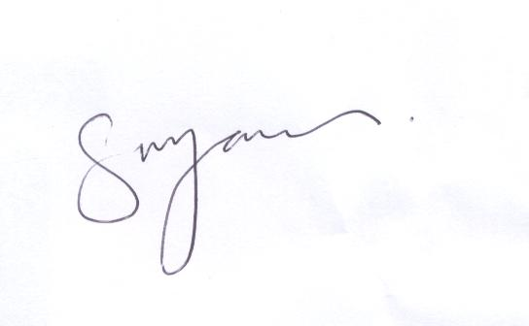
S M JONES
Headteacher

