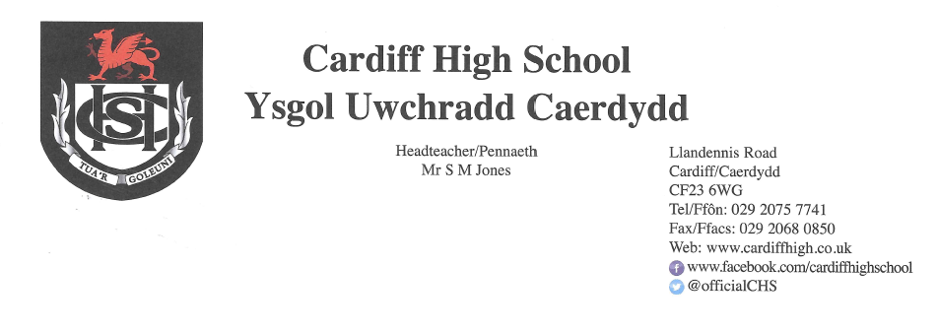
26 February 2021

Dear Parents and Carers,
As we return for the second half of this spring term, perhaps we may indulge in a little optimism and, science permitting, look forward to welcoming our learners on site in the near future.
Return to School
As you are probably aware, the Education Minister, Kirsty Williams, has stated that if conditions surrounding Covid-19 continue to improve, Years 11 and 13 will return to school, in some capacity, from 15 March. This, we believe will not be confirmed until the next Welsh Government review on 11 March. We will continue to update you and to share our specific plans as and when we receive the relevant information. Ms Williams has also made reference to the return of Years 10 and 12 prior to the remainder of the school population. We are currently awaiting further details surrounding this and, once again, will continue to update you accordingly.
If pupils are permitted to return during the latter end of this half term, it is likely that they may have outgrown some of their uniform and you will have found it difficult to replace items during the period of lockdown. For this reason, school uniform will be optional until the start of the summer term. By this time, it is likely that shops will have opened and non-essential items will be accessible. Our expectation is that pupils will return to school in our summer uniform following the Easter break. We will, of course, monitor this situation carefully.
Parents/Carers’ Consultation Events
Throughout these challenging times, we have been regularly reviewing and enhancing our approach to keeping in touch with families and providing meaningful feedback. We have, therefore, decided to offer parental/carer consultations with subject teachers via an online platform. In the first instance we have prioritised examination classes as follows:
Year 11 – 11th March
Year 13 – 17th March
Year 12 – 23rd March
Details regarding the practicalities of signing up for virtual appointments will be sent within a separate letter at the start of next week.
Information regarding remaining year groups will follow in due course.
Year 11 Options
Year 11 students will be sent an email on Wednesday 3 March which will contain the options grid for their AS subject choices. The e mail will provide a link to the Google Form which they will need to complete in order to select their options. This will be accompanied by a short video explaining what they need to do. The form will need to be submitted by 15 March at the latest.
Extra Curricular Yoga Sessions
We have been pleased with the uptake of our extra-curricular activities. In a bid to enhance this provision, whilst also being mindful of the need to focus on good mental health and wellbeing, we are delighted to be offering a trial of online yoga for our pupils and staff. Yoga offers a host of benefits: It develops inner awareness, focuses attention on the body's abilities at the present moment and helps develop strength of mind and body. It has long been associated with developing positive wellbeing.

The sessions will take place every Tuesday as of 2 March on a trial basis initially. A link to the sessions will be posted on your child’s form Google Classroom in advance. All participants will be muted by the instructor and your child is free to turn their camera on or off. If your child is interested in participating, the following form needs to be completed in advance of the session. https://forms.gle/apSVhsYiGMXyQRtX9

The sessions will be delivered by Lisa James, a highly experienced and respected yoga instructor who usually teaches from the Tramshed’s yoga studio. Of her teaching, Lisa states:

I first came to yoga in 2002, have been teaching since 2016 and continue to train and develop my own practice with a small group of exceptional teachers across the UK.
My personal experience with yoga has been to see my practice far outgrow its role as a physical exercise to provide me with immense emotional support - and that's what I hope to pass on in my teaching. You can expect my classes to reflect this.

Importantly, I'm committed to teaching in a way that's inclusive and accessible, where everyone is welcome. Together we'll practice a collection of traditional and complementary movement, breath and meditation practices communicated in a way that's clear, honest and authentic - and I can't wait to get started!

Covid-19
Thank you for continuing to update us of positive tests for Covid-19. If your child receives a positive test for Covid-19 during this period of lockdown please can you continue to let us know, for our records, by emailing Mrs Allison Yarrow yarrowa@hwbcymru.net
Please continue to use our website and follow our Twitter page for further updates and information.
Yours sincerely
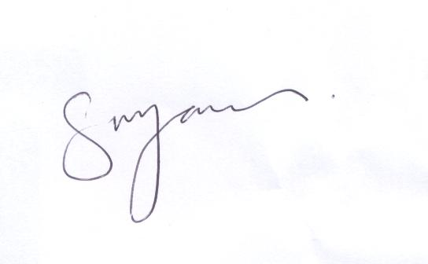
S M JONES
Headteacher

