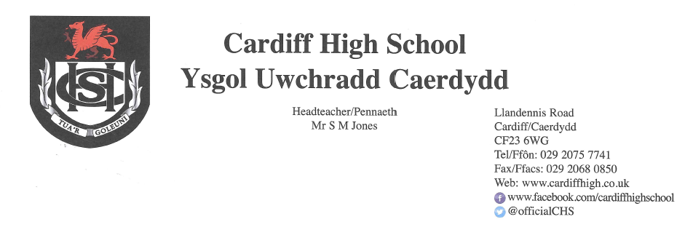
5 March 2021

Dear Parents and Carers,
As you are probably aware, a great deal has happened throughout the course of this week and we would like, as always, to update you regarding our responses on a number of key issues.
Return to School
In last week’s letter, I outlined the fact that the Education Minister, Kirsty Williams, has stated that if conditions surrounding Covid-19 continue to improve, Years 11 and 13 will return to school, in some capacity, from 15 March followed by Years 10 and 12. You are probably aware that earlier this week, Ms Williams stated that learners in the remaining year groups would also be given an opportunity to attend school for a “check-in” with teachers in readiness for a return after Easter.
Our current plan is as follows but we would please ask you to bear in mind that this will be dependent upon a number of factors including Welsh Government announcements and local transmission rates.
Year 13 and Year 11 – Return on 15 March
Year 12 - Return on 17 March
Year 10 – Return on 18 March
Year 9 – Attend school on Friday 19 and Monday 22 March
Year 8 – Attend school on Tuesday 23 and Wednesday 24 March
Year 7 – Attend school on Thursday 25 and Friday 26 March
During this period, pupils follow their normal time table. When pupils are at home, all lessons will be of a “live” nature. For pupils attending “live” lessons at home, there will be a separate time schedule distributed towards the end of next week. All home based “live” lessons will be half an hour long in order to minimise screen time for pupils and to accommodate the combination of face to face and home learning for staff.
We appreciate that pupils are a little anxious about the relative short notice period for completion of outstanding work prior to returning to school; we have, therefore, taken on board their request for time. As a result, there will be no live lessons, webinars or independent study periods on Tuesday 9 March.
Please note that there will be no canteen provision during the period 15 March to 26 March and we would advise that your child brings sufficient snacks, lunch and drinks for the day. Water will be available to purchase from reception.
Pupils in Year 7 and Year 8 will continue with the early dismissal ie Year 7 will finish school at 2.50pm, Year 8 at 3.00pm. The remainder of pupils will finish the school day at 3.10pm.
As previously advised, pupils may attend school in casual but appropriate clothing during this period with the expectation that they return in uniform following the Easter break.
Face Coverings
Pupils will be expected to continue to wear face coverings whilst in communal areas of the school. Recent guidance from Welsh Government refers to the wearing of face coverings and states that “..if social distancing cannot be maintained, face coverings should be worn anywhere on the school estate, including in the classroom.”
Testing of Staff
The Welsh Government has recently announced that it will start a programme of asymptomatic COVID-19 testing in education and childcare settings across Wales. Along with the primary protective measures we are taking, testing will allow us to take further measures to help pupils and staff members to continue working in as safe an environment as possible. All staff are being asked to take part in twice weekly home testing using Lateral Flow Device (LFT) tests. If the test is positive, staff and their close contacts will immediately need to start self-isolating, and a second test will be arranged to confirm the results. If the confirmation test is negative, all those who have been asked to isolate will be able to return to school. If the confirmation test is positive, the self-isolation period will continue for a total of 10 days.
If a member of staff working with a pupil contact group records a positive LFT result, this may mean that pupils within the contact group will need to self-isolate. Given the routine nature of the testing, this may mean that you may be notified that your child should not attend school at very short notice.
If your child is required to self-isolate in the above circumstances and the staff member then receives a negative confirmation test result, they and close contacts, including pupils within the contact group, will be able to return to school and we will let you know this as soon as possible.

Testing of Pupils
The Minister for Education and the Minister for Health and Social Services also announced on 22 February that the offer of regular, twice weekly, Lateral Flow Tests will be extended to all those of upper secondary age. These tests will be for use at home. This will start with offering tests to learners in years 10 and above. We are awaiting on further information regarding this and will update you as soon as possible.
Assessments and Qualifications (Key Stage 4 & 5)
The WJEC has now published the Initial Assessment Framework for individual subjects and qualifications. We will be working very hard over the coming days to as individual departments and as a whole school to determine Cardiff High School Assessment Plans. Our aim is to share this with you during the course of next week. In the meantime, I would like to reassure you that within the two weeks of school prior to the Easter holiday, we will not be setting formal assessments for any examination groups. Work will continue on non-exam assessments (NEAs) and assessment preparation.
Parents/Carers’ Consultation Events
As highlighted in previous letters, the first of our Parents/Carers Consultation events will take place on Thursday 11 March. In order for staff to arrange as many meetings as possible, there will be no live lessons for P4 and P5 on this day. These will be replaced either by webinars or guided independent study.
Details regarding the practicalities of the event were sent at the start of this week for families with a child in Year 11.
Extra Curricular Yoga Sessions
This proved to be very well received last week by staff and learners alike. The second session will run on Tuesday 9th March at 4.00pm. A link to the session will be posted on your child’s form Google Classroom in advance. All participants will be muted by the instructor and your child is free to turn their camera on or off. If your child is interested in participating, the following form needs to be completed in advance of the session. If your child has already submitted this form, there is no need to do so again.
https://forms.gle/apSVhsYiGMXyQRtX9

Covid-19
Thank you for continuing to update us of positive tests for Covid-19. If your child receives a positive test for Covid-19 during this period of lockdown please can you continue to let us know, for our records, by emailing Mrs Allison Yarrow yarrowa@hwbcymru.net

Please continue to use our website and follow our Twitter page for further updates and information.
Yours sincerely
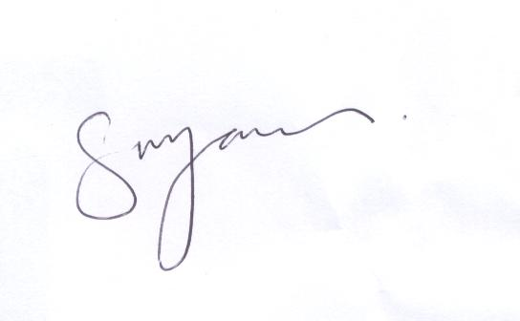
S M Jones
Headteacher

