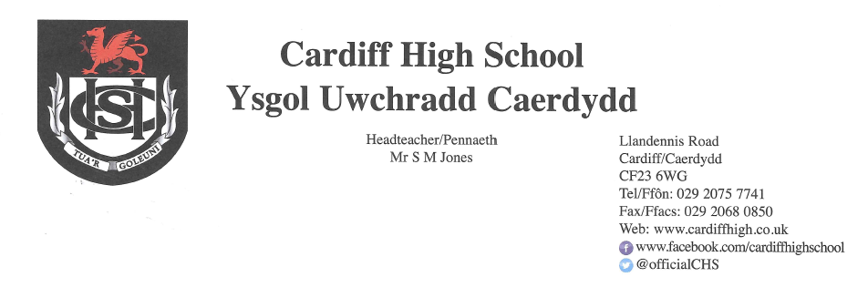
12 March 2021

Dear Parents and Carers,
We are very much looking forward to welcoming pupils back to school as of next week.
Return to School
Our plan remains as follows but we would please ask you to bear in mind that this will be dependent upon a number of factors including any Welsh Government announcements and local transmission rates.
Year 13 and Year 11 – Return on 15 March
Year 12 - Return on 17 March
Year 10 – Return on 18 March
Year 9 – Attend school on Friday 19 and Monday 22 March
Year 8 – Attend school on Tuesday 23 and Wednesday 24 March
Year 7 – Attend school on Thursday 25 and Friday 26 March
During this period, pupils will follow their normal time table. When pupils are at home, all lessons will be of a “live” nature. For pupils attending “live” lessons at home, a separate time schedule was sent via Parent Pay yesterday and a webinar regarding this is available on our website. All home based “live” lessons will be half an hour long in order to minimise screen time for pupils and to accommodate the combination of face to face and home learning for staff.
Please note that there will be no canteen provision during the period 15 March to 26 March and we would advise that your child brings sufficient snacks, lunch and drinks for the day. Water will be available to purchase from reception.
We will maintain our mitigation measures as they stood prior to this period of lockdown. This will include, designated zones for pupils during break and lunchtimes; staggered lunch breaks; a one way system; the ventilation of classrooms; organisation of desks in a forward facing arrangement; hand sanitiser available in key areas including classroom entrances; phased dismissal.
Year 7 will finish school at 2.50pm, Year 8 at 3pm. The remainder of pupils will finish the school day at 3.10pm.
As previously advised, pupils may attend school in casual but appropriate clothing during this period with the expectation that they return in uniform following the Easter break.
Face Coverings
Pupils will be expected to continue to wear face coverings whilst in communal areas of the school. Recent guidance from Welsh Government refers to the wearing of face coverings and states that “..if social distancing cannot be maintained, face coverings should be worn anywhere on the school estate, including in the classroom.”
Qualifications 2021
Families with children in Years 10, 11, 12 and 13 will have already received some guidance providing further detail about our approach to awarding grades. We hope you found this useful, but we are aware that students will have lots of questions. We will be providing students with a pupil version of this guidance as soon as they come back to school and they will have an opportunity to ask questions. We understand that this is an anxious time for them and will do everything we can to support them as much as possible.
Testing of Pupils
The Minister for Education and the Minister for Health and Social Services recently announced that the offer of regular, twice weekly, Lateral Flow Tests will be extended to all those of upper secondary age. Pupils in years 10, 11, 12 and 13 are, therefore, being asked to take part in twice weekly home testing using Lateral Flow Device (LFT) tests. As consent is required prior to the provision of the tests, I have written to parents, carers and students of these year groups separately with further details and consent forms.
Parents/Carers’ Consultation Events
As highlighted in previous letters, the second of our Parents/Carers Consultation events will take place on 17 March for Year 13.
Details regarding the practicalities of the event have already been sent to families with a child in Year 13.
Extra Curricular Yoga Sessions
This proved to be very well received again last week by staff and learners alike. The third session will run on Tuesday 16 March at 4pm. A link to the session will be posted on your child’s form Google Classroom in advance. All participants will be muted by the instructor and your child is free to turn their camera on or off. If your child is interested in participating, the following form needs to be completed in advance of the session. If your child has already submitted this form, there is no need to do so again.
https://forms.gle/apSVhsYiGMXyQRtX9

Covid-19
Thank you for continuing to update us of positive tests for Covid-19. If your child receives a positive test for Covid-19 during this period of lockdown please can you continue to let us know, for our records, by emailing Mrs Allison Yarrow yarrowa@hwbcymru.net
Please continue to use our website and follow our Twitter page for further updates and information.
Yours sincerely
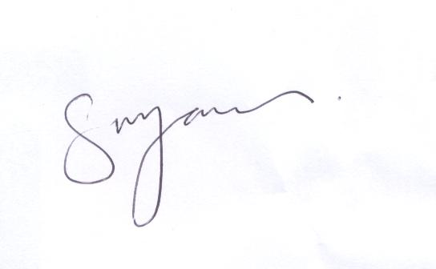
S M JONES
Headteacher

