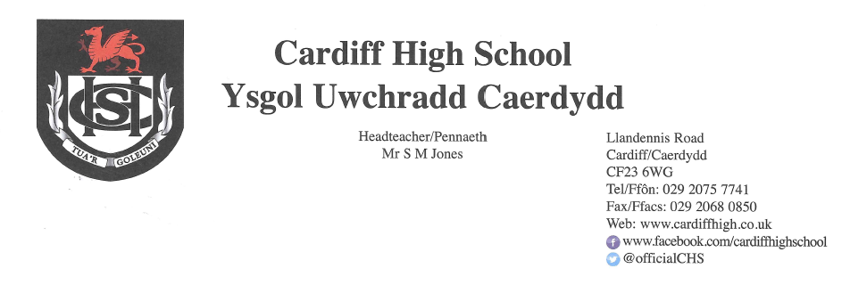

19 March 2021

Dear Parents and Carers,
It has been an absolute pleasure to welcome learners back to school this week. Attendance has been excellent at just over 96%. We now look forward to catching up with Year 7 and Year 8 next week. We would politely remind you that Year 7 will finish school at 2.50pm, Year 8 at 3.00pm. The remainder of pupils will finish the school day at 3.10pm.
Face Coverings
Pupils have displayed a very positive and mature attitude towards the wearing of face coverings in communal areas of the school. As highlighted in last week’s letter, recent guidance from Welsh Government refers to the wearing of face coverings and states that “if social distancing cannot be maintained, face coverings should be worn anywhere on the school estate, including in the classroom.” Staff are reminding pupils of this on a regular basis. If you would like your child to adhere to this protocol, and to wear a covering in lessons please may we suggest that you also remind them of this.
Testing of Pupils
Lateral Flow Tests have now been issued to pupils in years 10, 11, 12 and 13 where consent has been provided. Tests are being undertaken by pupils twice per week.
School Uniform
Since returning to school following the Christmas break, we have demonstrated flexibility in terms of relaxing the rules surrounding school uniform. As highlighted in previous letters, however, uniform will need to be worn during the summer term when all pupils will be back in school. This complies with Welsh Government recommendations and supports our mitigation measures to help ensure that contact groups remain within their designated lunch and break time zones. Pupils may choose to wear the winter or summer uniform.
Please be advised that during restrictions when non-essential retail is closed, many items can still be purchased in supermarkets and also online via the school stockist. Please see below for the link to YC Sports.
https://www.ycsports.com
Parents/Carers’ Consultation Events
As highlighted in previous letters, the third of our Parents/Carers Consultation events will take place on 23 March for Year 12. Details regarding the practicalities have already been sent to families with a child in Year 12.
May I take this opportunity to thank you for the highly positive feedback regarding the previous two events.
Centre Determined Grades – Access Arrangements

If your child is in Years 10, 11, 2 or 13, you will have received detailed information regarding the school’s approach to Centre Determined Grades. Please be assured that if your child is entitled to access arrangements, these will be provided during the assessment process.

Parental Support

We have been contacted by the Service Coordinator and Family Support Practitioner of a new service called Parent Talk Wales. There is no doubt that the pandemic has led to growing pressure for a number of parents and families. Parents in Wales can now access this new service to get support with anything that is worrying them about family life and parenting. It is a free and confidential service which is available to parents of 0 -19 year olds. For further information, please see the attached flyer or web site www.parent-talk.org.uk/wales

Covid-19
Thank you for continuing to update us of positive tests for Covid-19. If your child receives a positive test for Covid-19 please can you alert the school at once in order for contact tracing to be undertaken.
Please continue to use our website and follow our Twitter page for further updates and information.
Yours sincerely
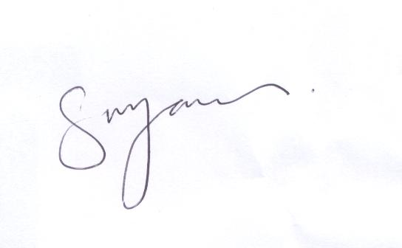
S M JONES
Headteacher

