The Cardiff Education Service is committed to providing eco-friendly and reusable period products to schools. Consequently, we are able to offer free packs to our pupils that will be contain some of the following items:

Eco-friendly disposable period products:
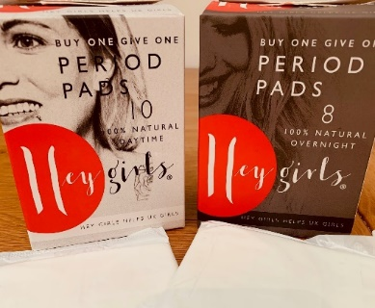
‘Hey Girls’ Daytime and Overnight period pads:

- Sustainable and environmentally-friendly
- Made from natural bamboo and corn fibre
- Chlorine and bleach free
- Wrapped in biodegradable film

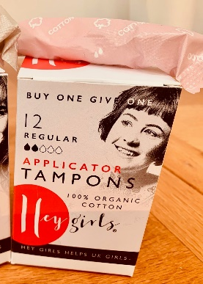
‘Hey Girls’ tampons – Regular

- 100% recyclable and plastic-free
- 100% organic cotton tampons
- Compact Bio-based applicator made from sugar cane
extract

Reusable period products:

Period Pants (Sporty) by ‘Cheeky Baby Products’:
- Main body of the pants is cotton/elastane (95%/5%),
with a waterproof outer layer
- Come with a wet bag (3 pairs per bag)
- Range of sizes available
- Useful link: How to care for period pants

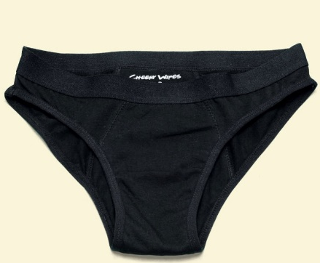
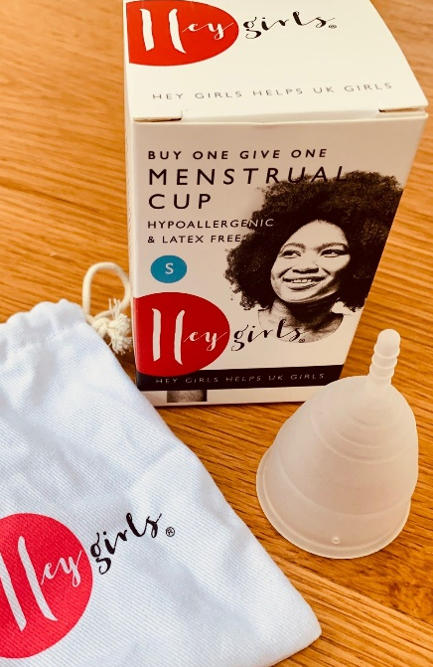
‘Hey Girls’ menstrual cups – Small:
- Made from 100% medical grade silicone
- Hypoallergenic and latex free
- Comes with cotton draw string pouch
- Can last for up to 10 years
- Useful links (click below):

How to use video: menstrual cups
(longer version - Give a Cup a Go)
How to care for menstrual cups

Interesting facts about standard period products
- Standards pads are made from up to 90% plastic. One estimate is a packet of pads is the equivalent of 5 plastic bags
- A standard pad will take over 500 years to decompose
- On average, a person who menstruates uses over 11,000 disposable menstrual items in their lifetime
- Standard tampons also contain plastic, especially those that have plastic applicators
- Issue of flushing products - blocking sewers, end up in sea and on beaches.

If you wish to have one of these packs there is a simple google form to complete so that the pack can be prepared. You can access this by using this link:

https://forms.gle/KnwQcQFjomPyZDBx6

Pupils will be informed via their hwb email where and when to collect the pack once they have arrived in school.

The deadline to complete the form is Friday 16th April 2021.

