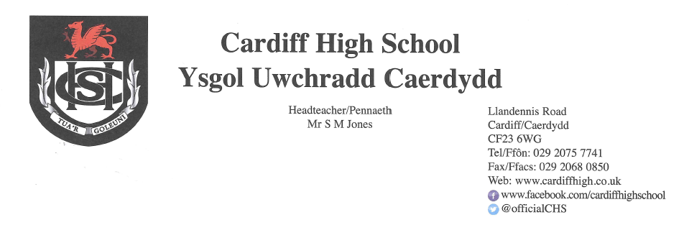
26 March 2021

Dear Parents and Carers,
Over the last two weeks, we have had the opportunity to welcome each year group back to school and it has been an absolute pleasure. Attendance has been excellent at just over 95%. We now look forward to a return to some sort of normality following the Easter break with all pupils attending each day. We would politely remind you that Year 7 will finish school at 2.50pm, Year 8 at 3.00pm. The remainder of pupils will finish the school day at 3.10pm.
Face Coverings
Most pupils have adopted a very mature approach to the wearing of face coverings; some, however, are forgetting to bring one each day. Please can we request that all pupils wear one as they arrive into the communal areas each morning and, perhaps, pack another as a spare.
Testing of Pupils
Lateral Flow Tests have now been issued in line with Welsh Government guidance and are being undertaken twice per week by staff and pupils in years 10, 11, 12 and 13. Please note, however, that if your child develops Covid-19 symptoms they are to seek a PCR test. The Lateral Flow Tests are designed to help identify individuals who are asymptomatic.
Covid-19
Thank you for continuing to update us of positive tests for Covid-19. If your child receives a positive test for Covid-19 please can you alert the school at once in order for contact tracing to be undertaken by e mailing yarrowA@hwbcymru.net.
Canteen Provision

Please be advised that our canteen will be operating as normal following the Easter break. Please may we politely request that your child's account is topped up by the lunch time of our first day back.

Qualifications 2021
In a bid to provide ease of access to the latest information regarding GCSEs, AS and A2 qualifications, a designated area of the school website has been created entitled “Qualifications 2021”. This will be updated on a regular basis in addition to the correspondence sent home.
School Uniform
As highlighted in previous letters, uniform will need to be worn during the summer term. This complies with Welsh Government recommendations and supports our mitigation measures to help ensure that contact groups remain within their designated lunch and break time zones. Pupils may choose to wear the winter or summer uniform. Please be advised that during restrictions when non-essential retail is closed, many items can still be purchased in supermarkets and also online via the school stockist. Please see below for the link to YC Sports.
https://www.ycsports.com
Cars on School Site

Whilst we have been able to accommodate family members driving on to the school site at the start and end of day in the last few weeks, following the Easter break when the school is operating at full capacity, this will not be possible. For health and safety reasons, unless there is a prior arrangement, please do not drive on to the school site. If you are dropping your child to school, or picking them up at the end of the day, please stop safely, away from the crossing and without disrupting the flow of traffic.

Music Peripatetic Instrument/Voice Lessons
We are pleased that this music provision will re-start following the Easter Holiday. Students who had lessons in person at school before the Christmas break will all be timetabled a slot for the first week back. Please email DaviesC433@hwbcymru.net to let us know of pupils who do not wish to continue. We will clarify the payment arrangements with you at the start of term.
Finally, thank you once again for your ongoing support throughout another challenging term. Enjoy the forthcoming holiday.
Please continue to use our website and follow our Twitter page for further updates and information.
Yours sincerely
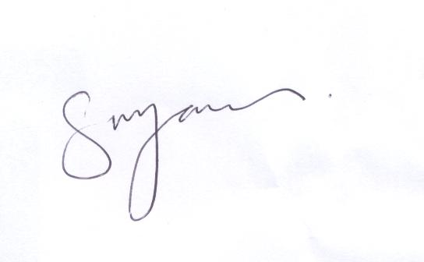
S M JONES
Headteacher

