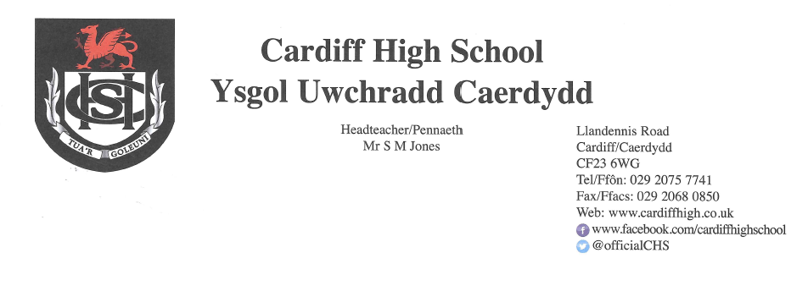
16 April 2021

Dear Parents and Carers,
It has been an absolute pleasure to welcome all of our learners back to school this week. Attendance has been excellent at just over 95% and attitudes towards learning have been highly positive.
Qualifications 2021
Please note that the latest information regarding GCSEs, AS and A2 qualifications can be located in a designated area of the school website entitled “Qualifications 2021”. This will be updated on a regular basis in addition to the correspondence sent home. Please may we politely remind you that pupils need to arrive promptly to lessons in order to begin their assessments on time.
School Uniform
We have, on the whole, been very pleased with the standard of uniform this week. Thank you for your support in this. It is much appreciated. As highlighted in previous letters, pupils may choose to wear the winter or summer uniform. Hoodies, however, are not permitted to be worn in school.
Covid-19
Thank you for continuing to update us of positive tests for Covid-19. If your child receives a positive test for Covid-19 please can you alert the school at once in order for contact tracing to be undertaken. Please email Mrs Yarrow yarrowa@hwbcymru.net
Face Coverings
The vast majority of our pupils have remembered to bring a face covering each day and are wearing them in communal areas. Staff will continue to remind pupils of the recommendation to wear mask in classrooms.

Testing of Pupils
As you are aware, Lateral Flow Tests have been issued in line with Welsh Government guidance and are being undertaken twice per week by staff and pupils in years 10, 11, 12 and 13. We have been notified by the Local Authority that this offer will be extended to all pupils in the near future. We will, as always, update you regarding this once the tests have been delivered to school. Please note, however, that if your child develops Covid-19 symptoms they are to seek a PCR test. The Lateral Flow Tests are designed to help identify individuals who are asymptomatic.

Extra-Curricular Activities
We are delighted with the wide range of extra-curricular activities that are being offered to the pupils and with the high level of uptake. Please see the school web site and follow our official Twitter page for further information.
Yours sincerely
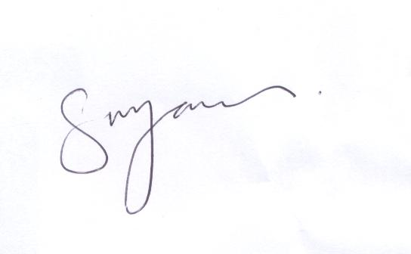

S M JONES
Headteacher

