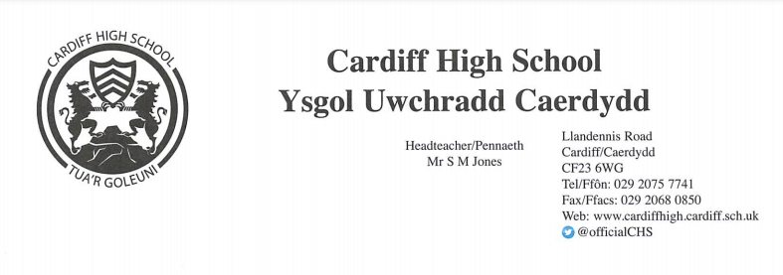
29 April 2022
Dear Parents and Carers,
We have enjoyed an excellent first week back. It has been very encouraging to see learners who are about to embark on the examination series return with a positive mindset and a clear determination to work hard. Attendance across the school has been excellent at 95%. Our summer enrichment opportunities have begun and are being enjoyed by learners across all key stages.
Please see below for a reminder of the information which we sent out during the Easter Break. We will now suspend the issuing of a weekly update letter unless further information is received. We will, of course, continue to tweet information relevant to school life and a newsletter will be issued at the end of the term.
Covid-19 Update
- Routine, asymptomatic Lateral Flow Tests are no longer required
- Schools will not be provided with Lateral Flow Tests for distribution
- If your child develops one of the “cardinal” symptoms (ie a new continuous cough, loss or change of taste or smell and/or high temperature) you are advised to order a lateral flow test online or to keep your child at home for five days
https://www.gov.uk/order-coronavirus-rapid-lateral-flow-tests
- For children experiencing mild cold like symptoms, they should attend school
- There is no longer a requirement for face coverings in school
- Physical distancing is no longer required

May I take this opportunity to wish you an enjoyable Bank Holiday weekend.

Yours sincerely

S M JONES
Headteacher

