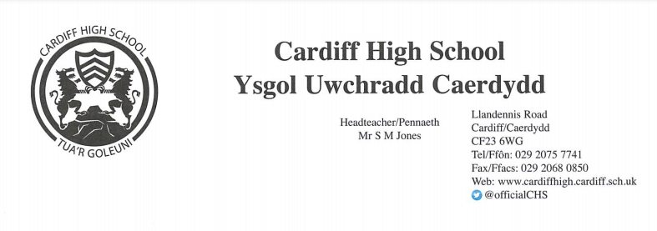

Dear Parent/Carer,

Staff at Cardiff High School are delighted to once again be offering a Summer Camp for Year 6 pupils during the start of the summer holidays. This programme will allow students to meet some of their future peers, teachers and get to know their way around their new school. This event will boost the pupils’ skills and confidence as well as being a fun experience at the start the summer holidays.

The programme will take place at: Cardiff High School
The dates for the programme are: 20th – 24th 2026
The times for the programme are: 9am - 3pm (AM: 9am-12pm & PM: 12pm – 3pm)

The Summer Camp will:
- Be led by experienced teachers & support staff
- Focus on creativity, literacy and numeracy skills during the morning sessions
- Promote team-work and communication skills
- Provide an opportunity to try new activities
- Enable pupils to explore the school and meet new friends
- Include lots of sports and games in the afternoon

As the Summer Camp runs for the full day, it is essential that children bring a packed lunch, snacks and plenty of liquids. There will be no facilities to purchase food and/or drink however we do have water fountains available. Many activities will be physically active and pupils will need to dress appropriately in comfortable clothes suitable for movement, and adequate footwear such as trainers.

The cost for each day will be charged at £40. Students can choose to attend the whole period or particular days/half days. Please clearly indicate the duration and dates that you wish your child to attend on the form below.

Places are limited across all five days and will be allocated on a first come, first served basis. The deadline for applications and payment is 03/07/2026.

If you would like your child to take part, please complete the application form by following the link below:
https://forms.gle/nuKD9L9f7RR44kBF6

If you experience any technical issues, please email JonesE3708@Hwbcymru.net for a PDF copy of the form. You will be sent confirmation via email if your child has been successful in obtaining a place prior to the end of the Summer term.

Yours faithfully,

Miss R. Foreman Mr T.Lazell Mrs E. Jones
(SC Co-Ordinator) (SCAssistant Co-Ordinator) (SC Administrator)
ForemanR@hwbcymru.net LazellT7@hwbcymru.net JonesE3708@Hwbcymru.net

