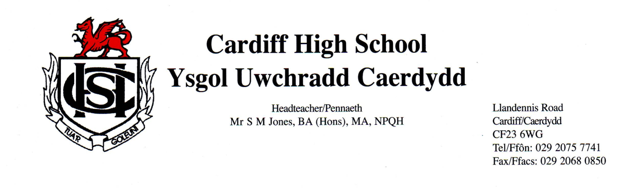
Dear Parent/Carer,
Chewing gum
I am contacting you to make you aware that we’re increasingly facing an issue with regards to chewing gum which is causing damage to students’ uniform, hair, exercise books and also school property such as desks, chairs, displays and IT equipment.
Please can we ask that you support the school in reminding your child or children that chewing gum is banned in school and packets of chewing gum will be confiscated if seen.
Many thanks for your continued support,
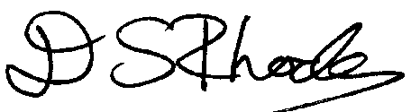
Mr David Rhodes
Senior Leader of Wellbeing & Achievement

