16 December 2020

To: all learners in years 11, 12 & 13

I am writing to give you some more information about how the assessments that are replacing your exams will work.

We cancelled exams for GCSEs, AS and A levels delivered by the WJEC in 2021 because of the effect Covid 19 has had on your education since March.

I asked a group of head teachers and college leaders to look at how your work could be assessed so that the grades you get in 2021 are fair despite the different experiences you have had, will help you progress and take your well-being into account. The group has also considered the many views of young people that have been shared with us through letters, emails, surveys and face to face meetings

How you will be assessed and when will it happen

I have accepted the advice they gave me and can confirm that for most subjects the work you have done will be assessed in three ways.
- non-examination assessments such as coursework or oral assessment (where these are already part of the qualification you are taking)
- internal assessments which will be marked by teachers and lecturers; and
- external assessments, marked by WJEC.

These are the only assessments that will count towards your grades in 2021 and we don’t expect you to have to do any of these until after the spring half term. The awarding organisation, the WJEC will provide the material for both the internal and external assessments and will share information in advance so that your teachers and lectures can help prepare you. Your teachers and lecturers will decide how and when these assessments take place so that they can be introduced as part of your learning.

The internal assessments will take place between 22 February and 23 April. This does not mean you will be continually assessed, just that there will be time to complete them, especially if there is any more disruption and periods of self-isolation.

The external assessments will take place between 17 May and 29 June. I know some learners have been worried about whether these are just exams by another name – that is not the case. Whilst there will be nationally set assessments that all learners across Wales will take, these will not be held under normal exam conditions, and won’t be sat at the same date and time, in an exam hall and in silence.

I know that the potential impact of assessments has been a worry for many of you, so the advice of the group has taken this into account. Your teachers and lecturers will decide how assessments take place. For example, they could be split over a number of lessons, done in the classroom so it is more relaxed and planned as part of your learning so you are more prepared.

I have heard direct from learners that you want qualifications you can be proud of and that’s what I am trying to do. While the assessments will challenge you, so that you are prepared for your next steps, they will also be fair and reflect the different circumstances you have faced.

What next

I know this letter may not give you all the details that you want. The awarding organisation, the WJEC will be providing more details to your teachers and lecturers at the start of the next term, including the key topics for both types of assessments.

Your teachers and lecturers will plan your learning to make sure you are well prepared and the existing adaptations made by WJEC will remain.
Please have a well-deserved and safe holiday. You have had a challenging year in 2020 and you and your teachers and lecturers deserve a proper break.

But remember Covid 19 spreads when people get together so please help Keep Wales Safe this Christmas by sticking to the rules and hopefully together we can stop infection from coming into our homes and into our schools and colleges.

Diolch yn fawr

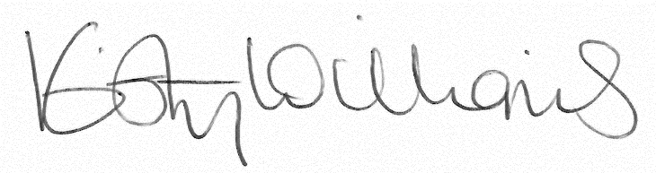

Kirsty Williams AC/AM
Y Gweinidog Addysg
Minister for Education

