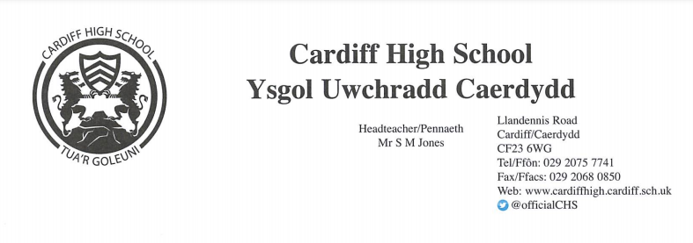

Dear Parent/Carer,

Staff at Cardiff High School are delighted to once again be offering a Summer School for Year 6 pupils during the start of the summer holidays. This programme will allow students to meet some of their future peers, teachers and get to know their way around their new school.

The programme will take place at: Cardiff High School
The dates for the programme are: 25th – 29th July 2022
1st – 5th August 2022
The times for the programme are: 9am - 3pm (AM: 9am-12pm & PM: 12pm – 3pm)

The Summer School will:
- Be staffed by experienced teachers and coaches
- Focus on numeracy, literacy and creativity skills during the morning sessions
- Promote team-work and communication skills

- Provide an opportunity to try new activities
- Enable pupils to explore the school and meet new friends
- Include lots of sports and games
This event will boost the pupils’ skills and confidence as well as being a fun experience over the summer holidays.

Students will be able to try out some of the variety of activities on offer at Cardiff High. Many activities will be physically active and pupils will need to dress appropriately in comfortable clothes suitable for movement, and adequate footwear such as trainers.

As the Summer School runs for the full day it is essential that children bring a packed lunch, snacks and plenty of liquids. There will be no facilities to purchase food and/or drink.

The cost for each day will be charged at £35. Students can choose to attend the whole period, one week or even particular days/half days. Please clearly indicate the duration and dates that you wish your child to attend on the consent form enclosed.

The running of the second week will go ahead if there is sufficient demand. If there is a need to close the Summer School early due to low numbers, we will issue a refund to those who have paid.

Places are limited across all ten days and will be allocated on a first come, first served basis. The deadline for applications and payment is 24/06/2022.

If you would like your child to take part, please complete and return the enclosed parental consent form and medical questionnaire. Please return the form together with payment (please make cheques payable to Cardiff High School) in a clearly labelled envelope addressed to Miss N O’Neil and referring to Summer School to Cardiff High School. If you would prefer to pay via bank transfer, please email OneilN6@hwbcymru.net. You will be sent confirmation via email if your child has been successful in obtaining a place prior to the end of the Summer term.

Please note this event is subject to COVID restrictions. Hand sanitiser and antibacterial wipes will be used by both pupils and staff throughout the day. Should your child display any COVID symptoms or is generally unwell, we kindly ask they do not attend. As the cost fully covers the running and staffing of the Summer School, we will unfortunately not be able to issue any refunds for absence/sickness.

Yours faithfully,

Miss R. Foreman Miss N. O’Neil
(Summer School Co-Ordinator) (Summer School Administrator)

Medical Questionnaire/Consent Form for CHS Summer School 2022

Your child’s name ______________________________________
Current School ______________________________________
Does your child have any physical or psychological condition that may affect him/her during the summer school? YES/NO
If yes, please give details ____________________________________________________________________
Please give details of any allergies we should be aware of: ________________________________________
If your child suffers from a particular medical complaint, please enclose a letter giving details.

When did your son/daughter last have a tetanus injection? __________________________________________________________________

Parental /Carer Contact Details

Name:_____________________________ Relationship to child:_______________________

Email (for confirmation of secured place):__________________________

Telephone: Home_____________________ Work_____________________ Mobile____________________

Alternative Emergency Contact

Name ____________________________ Relationship to child: _______________________

Telephone Number_________________________

I consent to any emergency medical treatment necessary during the summer school.

Full Name of Parent/Carer ____________________________________________

Signed _____________________________ Date ____________________

I/We give permission for _________________________to attend summer school on the following dates (please tick where appropriate)

 | ALL DAY | AM ONLY | PM ONLY
Monday 25th July
Tuesday 26th July
Wednesday 27th July
Thursday 28th July
Friday 29th July
 | ALL DAY | AM ONLY | PM ONLY
Monday 1st August
Tuesday 2nd August
Wednesday 3rd August
Thursday 4th August
Friday 5th August

I confirm that __________________________ will be collected / is able to walk home from Cardiff High’s Summer School each day. (please circle)

I will be paying the amount of ___________ by bank transfer / cash / cheque. (please circle)

If not paying via bank transfer, I enclose cash / a cheque (please circle) for __________ / N/A

Data Protection

The data requested will be stored on the school management information system in line with data protection legislation and our retention schedule. It will be used for the purposes outlined in our ‘Privacy Notice’ which is issued to parents/carers and pupils. Every effort is made to ensure the accuracy and security of personal date held by the school. Individuals have certain rights of access to personal information held on them which are also outlined in the privacy notice.

