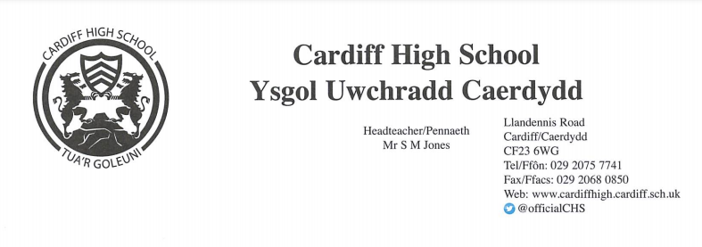

July 2022
Dear Parent/Carer
Please find enclosed your child’s end of year report. This provides a KS3 level for each subject.
I wrote to you last month to let you know that your child would be taking their online personalised assessments in reading and numeracy. These are the new version of the ‘National Tests’ that you may remember your child taking in previous years at primary school. Personalised assessments provide feedback on students’ reading and numeracy skills so that students, their teachers and their parents/carers can understand where they are in their learning journey and how to help them move forward.
Your child’s Maths and English teachers will use the information provided by this assessment to plan their next steps in learning. If, for any reason, your child has missed one or more of these assessments, please don’t worry as these assessments only form part of our continuing understanding of a pupil’s overall learning, alongside everything else they do throughout the year. There will be further opportunities to carry out these assessments every academic year up until the end of Key Stage 3.
The individual feedback from these assessments is provided electronically. Interactive PDF files can be found in your child’s online Hwb account. They should log on via the Hwb website: https://hwb.gov.wales/ and click the ‘Personalised assessments’ tab on the home page. The feedback documents will allow you to see both their result and sample questions for particular skills that a pupil answered well, and for skills that they have found more challenging.
For more information on the personalised assessments and the feedback that is given, please see the information from the Welsh Government here: https://hwb.gov.wales/curriculum-for-wales/reading-and-numeracy-assessments/personalised-assessments-information-for-parents-and-carers/
If you have any questions please don’t hesitate to get in touch with your child’s Achievement Leader or Head of Lower School, Mrs Venn.
Kind Regards,
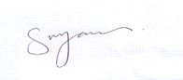

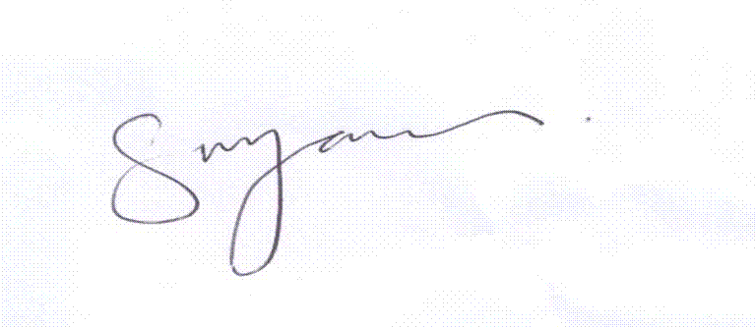
Mr. Stephen Jones
Headteacher
Mr. Stephen Jones
Headteacher
Mr. Stephen Jones
Headteacher
Mr. Stephen Jones
Headteacher

