5 February 2021

Dear Parents and Carers,
As we head towards the final week of a half term which has been extraordinary in so many ways, I would like to share with you a few updates and information.
Learner Feedback
As outlined in last week’s letter, throughout the course of next week (week beginning 8th February), learners will have the opportunity to “Catch Up and Tidy Up” within the independent study sessions on their blended learning time table. During these periods, learners will be able to “catch their breath”, complete outstanding work, organise notes and generally feel on top of their blended learning. Similarly, staff have been asked to avoid setting additional tasks to be undertaken in the half term break and to designate the INSET day of 12th February as a screen free day. If, however, your child wishes to continue working on outstanding tasks on this day, they can of course do so.
Finished an Exercise Book?

A number of learners have been in touch to say that, in certain subjects, they are coming to the end of their exercise books. Should you wish to obtain a new book for your child in any subject, please can we politely request that you contact reception and notify them of the fact that you will be coming in to school to pick up an exercise book and one will be ready for you upon your arrival. If, however, you would prefer to obtain your own notebook from another source this is no problem. There is no compulsion for the exercise book to be subject specific in the current climate.

Children's Mental Health Week

In the context of the current pandemic, we remain acutely aware of the need to look after our mental health. At Cardiff High School, this has remained a priority for us since the onset of the pandemic and we continue to utilise a wide range of strategies to support our learners in this vitally important area.

The children's mental health charity Place2Be has initiated Children's Mental Health Week 2021. Its aim is to highlight the importance of mental health within children and young people.

This year, in 2021, Children's Mental Health Week will take place from February 1st to February 7th.

With this in mind, we would like to encourage you to visit the area dedicated to wellbeing on our website and to follow our wellbeing Twitter account @ChsWellbeing for updates, literature and suggested strategies.
Additionally, please find attached a copy of our Health and Wellbeing Home Activities for Families which provides a host of useful links and ideas to support positive mental health.

Live KS3 and KS4 Games lessons

Following a highly successful fortnight of live games sessions for Key Stage 3 learners, we are delighted to confirm that lessons will be continuing in this format and will now also be offered to all pupils in Key Stage 4. also include. A meeting link will be posted in your child’s Google Classroom at the start of the lesson allowing them to engage in a teacher lead lesson.

We will continue to post activities as normal during Games lessons, but we would encourage pupils to attend these live lessons and actively engage with us.

The Winter Reading Challenge

The Winter Reading Challenge, led by our English department, has been extended! In light of the current climate, we felt it only right to allow more time for the completion of the challenge. Please see attached for specific details but in summary:

- Learners are encouraged to read 6 different texts (or listen to audiobooks) that meet the challenge criteria (see attached)
- The prize is a £50 book token or Amazon voucher (selected by lucky dip)
- All year groups are welcome to take part
- If your child has already completed the challenge then they are able to enter multiple times to increase the odds of winning
- Entries will need to be submitted (via a Google Form to be shared next week) by Monday 22nd February!

Please follow @EnglishCHS or contact the English Department for book recommendations.

A Date for Your Diary

As highlighted in last few letters, the Sixth Form Charity Committee members are currently working really hard to prepare a fun filled five round family quiz in readiness for the February half term holiday – week beginning 15th February. The entrance fee will be a small sum of £2. The pupils would be very grateful for your participation, as they endeavour to raise much needed funds for 'Kids Cancer Charity' and 'AP Cymru.' Additional information will be available in next week’s letter. Prizes include £100 and £50 Amazon vouchers which have kindly been donated to the cause.

Covid-19
Thank you for continuing to update us of positive tests for Covid-19. If your child receives a positive test for Covid-19 during this period of lockdown please can you continue to let us know, for our records, by emailing Mrs Allison Yarrow yarrowa@hwbcymru.net
Please continue to use our website and follow our Twitter page for further updates and information.
Yours sincerely
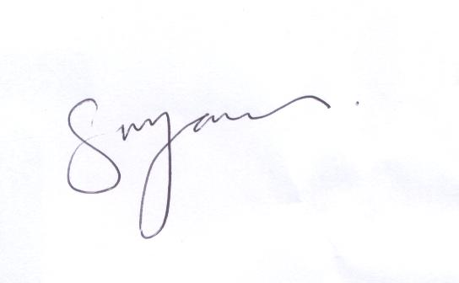
S M Jones
Headteacher

